Mossyrock School District - Vicinity Map

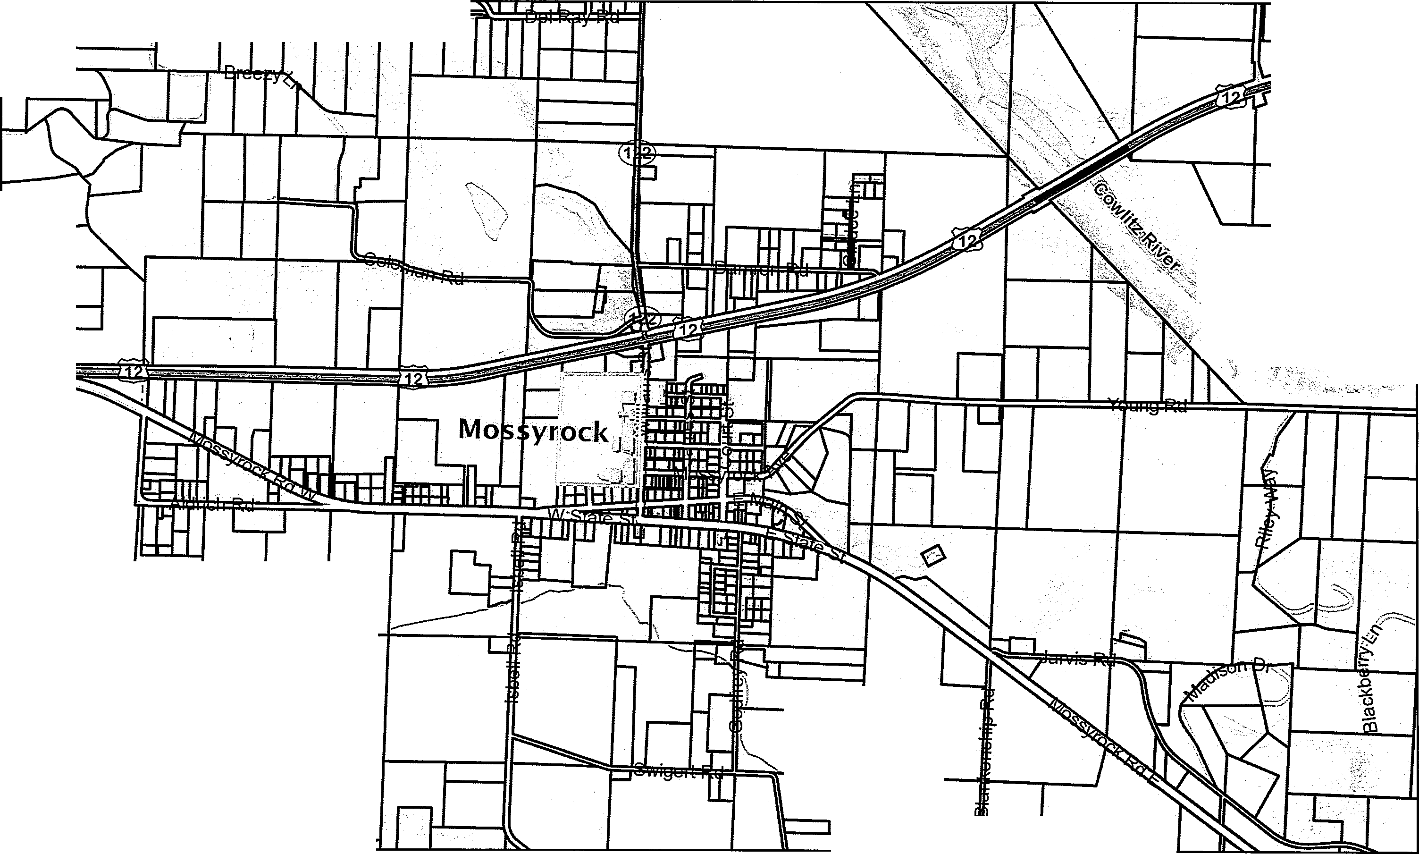
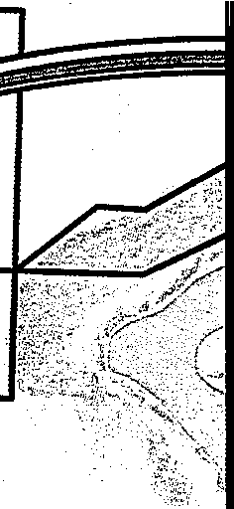
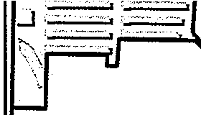

(," 7:!
'·tJ -t> 11,._. ,,,,

,---..._
.{I
s:kitat ek,/'

· •_,,;,,;;. ;,_

j
--

ck4ta;;,Gree1r

9/2/2021, 2:11:13 PM
□
Parcels
,I_,_,(
..,
..--------.,

0 800

1:18,056

1,600 3,200 ft

Subject Parcel NAD 1983 StatePlane Washington South FIPS 4602 Feet
--

Lewis County does not guarantee the accuracy of the information shown on this map and is not responsible for any use or misuse by others regarding this material. It is provided for general informational purposes only. This map does not meet legal, engineering, or survey standards. Please practice due diligence and consult with licensed experts before making decisions.
LEWIS COUNTY

- ,,,.,1.£.. fS-J'S -

