City Approval Form
This form is for buildings proposed inside city limits of Morton, Mossyrock, Pe Ell, and Toledo. This form is to certify that a proposed project complies with the city's development regulations prior to the applicant submitting a building permit at the Lewis County Community Development Office. The applicant is required to bring the following to the City with Jurisdiction for pre-approval and is responsible to pay any associated fees adopted by the city.
Completed 'City Pre-Application' form
Completed site plan meeting the 'Site Plan Requirements' handout (attached) Completed Lewis County Building Permit Application (attached)
City of Jurisdiction:
Full Project Description:
Tax Parcel Number (s):

Site Address:
Owner’s Name:
Owner’s Address:
Owner’s Phone Number: Owner’s Email:

Applicant Information:
Name:
Mailing Address:

Phone Number:

Acknowledgment
E-mail:

I, the property owner, applicant or authorized official, have read and understood the information of this form and the associated 'City Pre-Application Project Details' form attached and the information is correct to the best of my knowledge.

Signature: Date:

For Official Use Only

Zoning and Critical Areas:
Zoning: Is this project in compliance with the zoning regulations? Does this project meet setbacks from property lines? Yes No

Yes No

Was SEPA Completed?
Yes
No If no, what exemption applies?
WAC 197-11-800 or locally adopted modification

Critical Areas on property:
Wetlands Streams Flood Plain Shoreline
No critical areas were identified
Geologically Hazardous Areas Critical Aquifer Recharge
Other:

Critical area reports submitted:

Water Service:
No water service required Preexisting water service
New water service or additional connection required: Installation and monthly service fee explained Shut off procedures for non-payment explained Water hook fee up paid

Sewer Service:
No sewer service required Preexisting sewer service Septic installation required
New sewer service or additional connection required: Installation and monthly service fee explained Shut off procedures for non-payment explained Sewer hook up paid

Other:

Additional Comments:

I certify that I, city staff, have reviewed this form, the attached site plan, and the attached building permit application for development standards inside the City Limits and the project as described meets the requirements for the following:

Zoning and Critical Areas Water Service
Sewer Service
Other:
Acknowledged by the Planning Committee on:

Site inspection completed on: Not required
Not required

Approval of Authorized City Official

Signature: Title: Date: Signature: Title: Date:

The application is not authorized by the city with jurisdiction unless signed and dated by a City Official.

SITE PLAN REQUIREMENTS
This checklist is intended to give a general idea of the information required for a site plan. The application should NOT be submitted unless all points below are addressed. The checklist must be submitted with the application. Submit multiple maps if necessary. Additional information may be requested.
Any additional information which the applicant feels will assist in evaluating the proposal is encouraged.
Minimum size is 8.5x11-Maxiumim size is 11x17

STAFF

APPLICANT
North arrow
□

Vicinity map with location and name of all roads surrounding the property All property lines (if the parcel is large, provide a close up)
□
Setbacks from property lines for all proposed structures if an accurate scale is not provided
Location and identification of all existing and proposed structures with dimensions. Examples including, but not limited to: houses, sheds, barns, fences, culverts, bridges, retaining walls, and decks
Distance from other structures if within 10 feet

Test holes, septic tanks, septic lines, drainfields, and reserve areas
□

Wells, well circles with a 100-foot radius, water lines, etc. and all utility easements
□

Distance between existing and proposed septic, wells, and buildings

Location of all existing or proposed driveways and dimensions, easements, access roads etc. If there is an access easement, please provide a copy
Location and identification of any known critical areas on site. Examples including, but not limited to, wetlands, streams or other surface waters, steep slopes, etc.
□
Location of any known and proposed stormwater facilities Location, depth, and extent of any clearing, grading and filling
For all projects other than a single family dwelling, a description of the proposed use is
required. Examples include, but are not limited to: personal storage, commercial uses, agricultural uses, garage, etc.

":,t
0
•/-450'

RESERVE oEPTIC
0 5fPTJC TEST f'ITS t
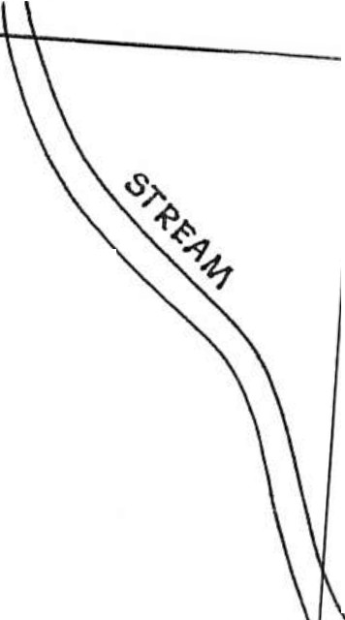
N.
\

<: AREA 0
SCALF J",, So

-----------_ ...

---
U)
I-
1M
1/)
-0
.S:!
-

PROPOSED 5E"PTIC

o'A

\
\

PRAWINi; By
PAT AI-IOEltsoN


^{'-} ' oiv.
c'i­
' o_;,'€.-<:..?>
...,, \'l-0
R£t:>llci;;p SAMPL

-J
85,
.,

s◊ ...
"' ' '
' ' '
'"
0 DRAIN IELD 0
' ' \
\
'1i

-.,....
I

'l('k

'i \Y
\ SEPTIC
f-lTANI<.
LW\ I--- :::r::-
.

-PROPOSED
2025 S.F.
PROPOSED
\ 'loo s.F.
I,'
GARAGE

\

0
XI •. Ln
□

WELL
.
3 BDRM HOME
•'.
I\
I I
I I
,' 5HED
I
I
(\,I
' -+-t..

.. 135' SETI!,ACK
. I 1 '

\

\ JOO' WEU. RADIUS

' ' '
'' ',
' ' ' -

:l
<.)

1-
w
<ll
0
cO
.-,.!.

, ,
,,.
, ,

I
I
.

,.I

ti.
UI

0
' . 47' PROPOSED DRIVEWAY ADDITION

f:,o' EXISTING DRIVEWAY.

PARCEL NO.
SITE ADORcss CONTACT NAM! PI-IONE No.
DATE

- - ---- -------
+/- 2101 ROAD APPROACH
0..

+/-42,;• "PROPERTY LINES

COUNTY ROAD

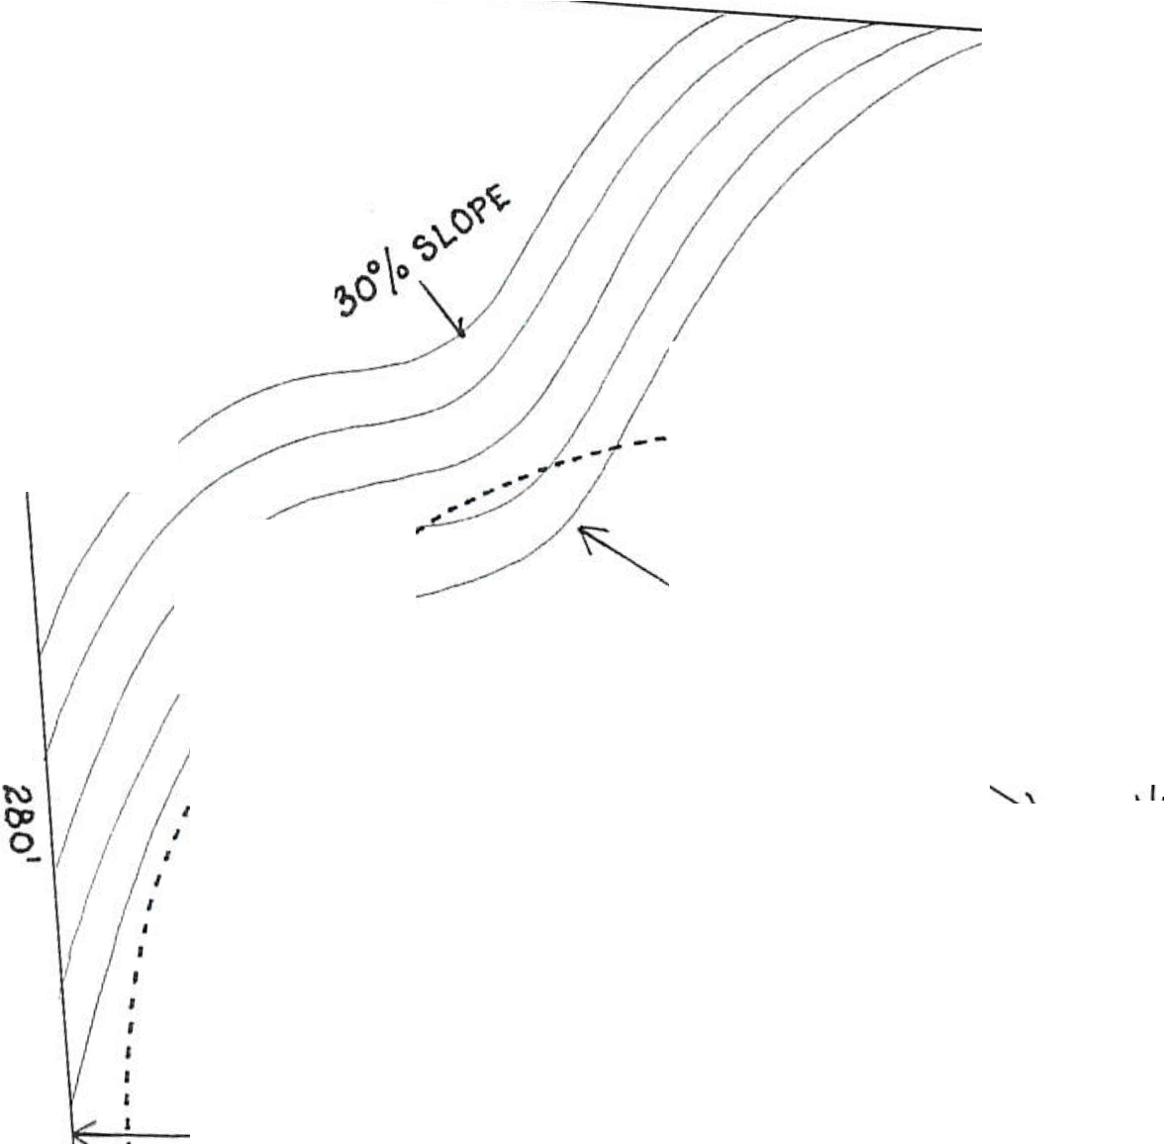
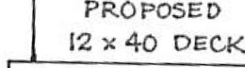
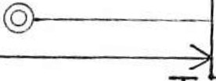
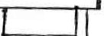
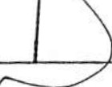

Lewis County Community Development
2025 NE Kresky Ave, Chehalis, WA 98532 ● Phone: (360) 740-1146 ● Fax: (360) 740-1245
Permit Number: MSR:
Date Submitted: Permit Technician:

BUILDING PERMIT

This Project is: Residential Commercial
Select all that apply:
Building Plumbing Mechanical Demolition Other

Project Description:
(Please attach additional sheets if needed)

Property Information:
Tax Parcel Number: Site Address: Owner’s Name: Phone Number: Owner’s Mailing Address: Email:
Applicant Information (if different): Owner Contractor Other:
Name: Phone Number:

Mailing Address: Email:

Project Information:
Contact when permit is ready or more information is required: Owner Applicant
Self-Built: Name: Phone: Contractor’s Name: Phone:
L&I License #: L&I Expiration Date: Address:
Valuation/ Bid Price: # of bedrooms: # of bathrooms: Construction Type: Occupancy:
Square Feet: Main: Second: Garage: Decks/Porches:

Finished Basement: Unfinished Basement:
Acknowledgment and Permission to Enter
Other:

I understand that County regulations require owner permission for County personnel to enter private property to conduct permit processing, review, and inspections. I also understand that my failure to grant permission to enter may result in denial or withdrawal of a permit or approval. By my signature below, permission is granted for representatives of the Community Development, Environmental Services, and Public Works Department to enter and remain on and about the property for the sole purpose of processing such permits and performing required inspections or reviews.
Prior notification of the date of inspections will take place is: Required Not Required
( ) (Must provide phone number where applicant/representative can be reached)
I/We certify that all plans, specifications and other submissions required in support of this application conform to the requirements of all federal, state, and local codes and applicable laws and ordinances; and I certify that I am either the current legal owner of this property or their authorized representative. With this document, I take full responsibility for the lawful action that this document allows.
I certify that I have read and understand the limitations and conditions of Lewis County Code and agree to comply with all conditions of approval. I understand that any permits issued by Lewis County, consistent with the attached site plan, are valid ONLY if construction is in according to this plan and all other conditions of the permit are followed. By my signature below, I affirm that all the information and documents provided with this application are true and accurate to the best of my knowledge.

Signature: Date: Fees Due: Check one: Owner Authorized Agent

FOR OFFICIAL USE ONLY:
Zoning: Flood Zone: FIRM Panel #: Lot: Blk: Division/Short Plat:
Quarter Section, Section , Township North, Range East/West (Circle One)
Plumbing |  | Mechanical |  | Fees
Supplemental Fee |  | Supplemental Fee |  | Building Permit Base Fee
Non Supplemental Fee |  | Non Supplemental Fee |  | Plan Review
Plumbing Fixtures: |  | Mechanical Fixtures: |  | Plumbing Fees
 |  |  |  | Mechanical Fees
 |  |  |  | State Building Code
 |  |  |  | Additional Fees
 |  |  |  | Oversized Copy Charge
 |  |  |  | Total Building Fees
Additional Reviews
Geo tech Report Received: Yes No Driveway Review Required: Yes No

Conditions / Inspection added to Adept: Yes No Reviewed By:
Sewer Availability Received: Municipal WAN Received:
New Septic Approval: Public Water Supply:
Permit #: Date Issued: Individual Well:
Number of Bedrooms: Well Log Received: Gallons Per Min:
Septic Reconnect Approval: Date Well Drilled: Permit #: Date Issued: WRIA:
Original Permit #: Covenant Required: Yes No AFN:
Number of Bedrooms:
Building Plans Approved:

Notes: Date:

