MOSSYROCK PLANNING COMMISSION
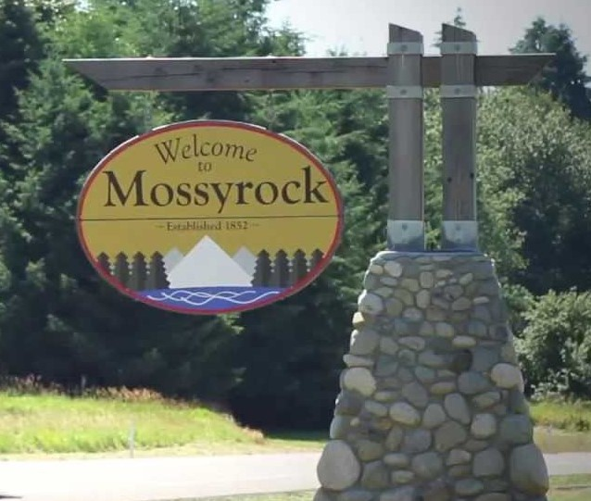
AGENDA
Monday; May 11, 2026
at the Mossyrock Community Center
Members:  Marcia Manley, Chair  Dean Guyer  Damon Stevens  Vacant  Vacant  City of Mossyrock  231 E. State Street  Mossyrock, WA 98564  360-983-3300  City website:  www.cityofmossyrock.com | 5 p.m. WORKSHOP  - Animal/Livestock Ord. #520  5:30 p.m. HEARING and Public Testimony  - Critical Ares Ord. #____  - Climate Elements – GMA Update  - Animal/Livestock Ord. #520  - p.m. BUSINESS MEETING  - CALL TO ORDER  - Pledge of Allegiance  - ROLL CALL  - APPROVAL OF AGENDA – As presented  - APPROVAL OF MINUTES  February 9, 2026 Meeting Minutes.  - Summary of March City Council Mtg  OLD BUSINESS  - Critical Ares Ord. #____ Recommendation.  - Climate Elements – GMA Update Recommendation.  - RV Ord. #514 Status update  - Animal/Livestock Ord. #520 – Recommendation.  NEW BUSINESS  None proposed  PUBLIC COMMENTS – Non-Agenda items  ADJOURN

